Key for values on Figure A:
D1,D2,D3,D4,etc: | Diameter of pipe (Excluding insulation).
L2,L3,L4,etc: | Distance between pipe centre and the next pipe centre.
H1,H2,etc: | Height from ceiling to pipe centre.
RL: | Length of rail or horizontal allowance.
L1: | Distance between wall to first pipe centre.
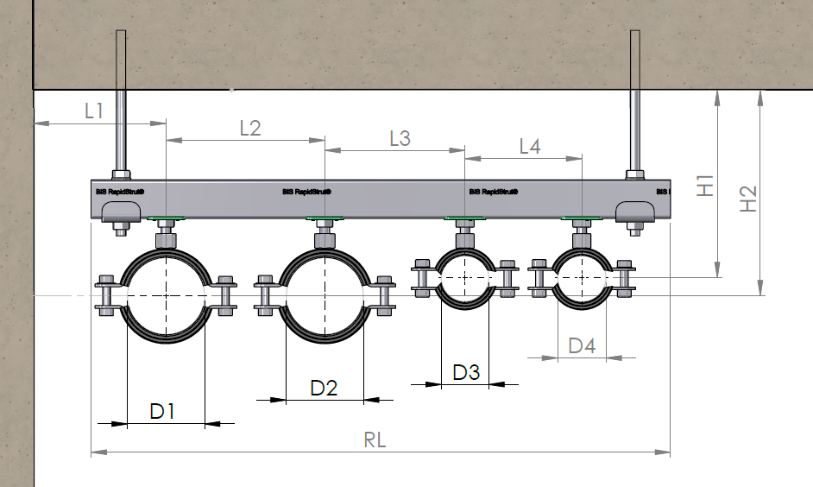
Figure A

Essential information*
Specific details for pipe support, for rail selecting software
Substrate material (C25 concrete Etc)*:
Pipe NO. | Pipe OD  (D1,D2,etc) * | Insulation thickness  (If applicable) |  | Distance from centre of pipe to next (L2,L3,etc).* | Material of pipe *  (Metal, plastic, etc) | Weight per meter of pipe  Kg/m /…/ N/m | Expansion?  Or Running Temperature | Length of rail (RL)*
Pipe 1
Pipe 2
Pipe 3
Pipe 4
Pipe 5
For additional pipework please fill out a second sheet and attach in reference.
Additional information to complete mark up |  | Any other Requirements - Support environment (Swimming pool Etc.)
Distance from pipework to ceiling (H1,H2,etc). * | H1: H2: H5:  H2: H4: H6:
Distance between pipework spans
(If specified).

